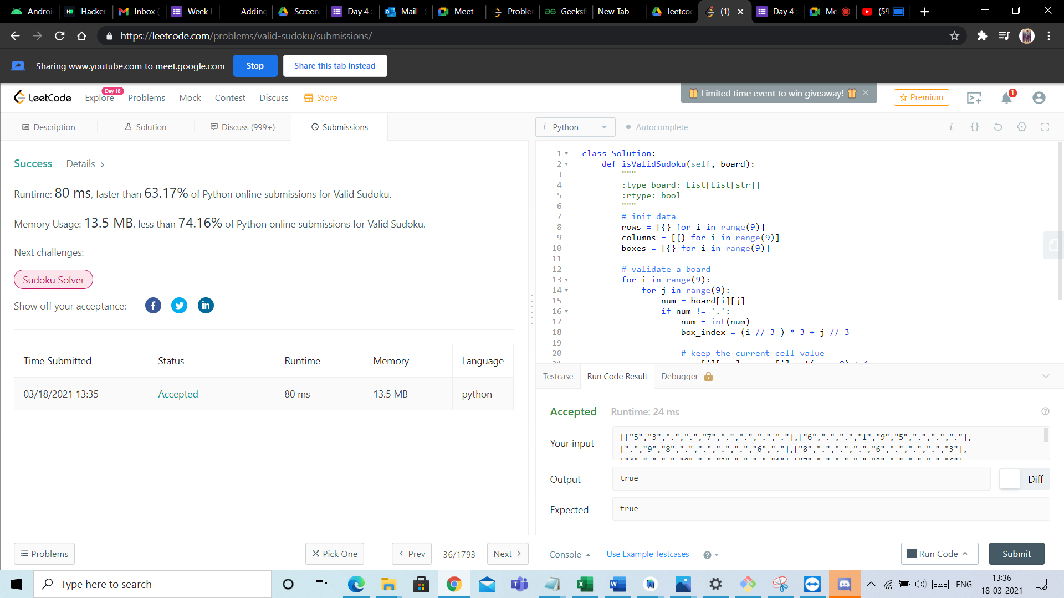

Androi

Hu Hacker

M Inbox

E Week 1 |

Adding

A Screen

Day 4: o Mail -

01 Meet -

**Probler 26 Geeksf**

**New Tab**

**Aleetco**

G (1

E Day 4: o Me

(59

+

C

o

. https://leetcode.com/problems/valid-sudoku/submissions/

Sharing www.youtube.com to meet.google.com

**Stop**

Share this tab instead

Day 18

CleetCode

Explore

Problems

Mock

Contest

Discuss

Store

i Limited time event to win giveaway! T X

* Premium

Et

too

3 Description

8 Solution

Discuss (999+)

Submissions

i Python

• Autocomplete

Success

Details »

class Solution:

def isValidSudoku(self, board):

Runtime: 80 ms, faster than 63.17% of Python online submissions for Valid Sudoku.

ovo AWN

: type board: List[List[str]] :rtype: bool

Memory Usage: 13.5 MB, less than 74.16% of Python online submissions for Valid Sudoku.

# init data rows = [{} for i in range (9)] columns = [{} for i in range(9)] boxes = [{} for i in range(9)]

Next challenges:

Sudoku Solver

Show off your acceptance:

f

o covoin N

# validate a board for i in range(9): for j in range(9):

num = board[i][j] if num != '.':

num = int(num) box_index = (i // 3 ) * 3+; // 3

20

Time Submitted

Status

Runtime

Runtime

Memory

Language

# keep the current cell value

---.-r: ... --- -1:1 --Il-.. Debugger &

.

1

Testcase

Run Code Result

03/18/2021 13:35

Accepted

80 ms

13.5 MB

python

Accepted

Runtime: 24 ms

Your input

roc" 7"

c FI

C IL S . . . . . . 6 . ) 1 9

. . . FOR HECHICHI 98 . . . . 6 T , 8). .

6

.31,

Output

true

*Diff*

Expected

**true**

: Problems

X Pick One

< Prev

36/1793

Next >

Console.

Use Example Testcases

Run Code

Submit

13:36

1

Type here to search

o

v

^

"

EN

18-03-2021

L